REASONS FOR PREGNANCY AMONG WOMEN ON PREVENTION OF MOTHER-TO-CHILD TRANSMISSION (PMTCT) PROGRAM IN SEROWE-BOTSWANA

Muya Kanyinda (MD)

Student No: 200725929
Dissertation submitted in partial fulfillment of the requirements of the degree of Master of Public Health in the Faculty of the School of Public Health at the University of Limpopo (MEDUNSA Campus) Republic of South Africa

July 2009

SUPERVISOR: Ms. MATHLIDA MOKGATLE-NTHABU
CO-SUPERVISOR: DR. O.O.OGUNTIBEJU

TABLE OF CONTENTS
Heading Page

I. Chapter One: Introduction………………………………………………………..1
1.1. Background and Problem Statement.………………………………………………………….1
1.2. Research Question/s…………………………………………………………………................3
1.3. Study Aim……………………………………………………………………….........................3
1.4. Study Objectives……………………………………………………………….......................3
1.4. Study Area………………………………………………………………………………………………3
1.5. Study Justification or Rationale…………………………………………………………………4
1.6. Conclusion.……………………………………………………………………………………………..4
II. Chapter Two: Literature Review……………………………………………….6
2.1. Introduction.…………………………………………………………………….......................6

. Relationship of Knowledge of HIV status and Reproductive Choice……………….6

. Social and Cultural Influences…………………………………………………..................8

. Family Planning Practices………………………………………………………………………….10

. Botswana………………………………………………………………………........................11

. Conclusion…………………………………………………………………………………………….11
III. Chapter Three: Methodology…………………………………………………13
3.1. Introduction……………………………………………………………………......................13

3.2. Study Design………………………………………………………………………………………….13
3.3. Study Setting…………………………………………………………………….....................13
3.4. Study Sample.………………..………………………………………………………………………13
3.5. Data Collection Methods…………………………………………………………………………14
3.6. Ethical Considerations.…………………………………………………………………………..14
3.7. Conclusion.……………………………………………………………………........................15
IV. Chapter Four: Data Analysis…………………………………………………..16
4.1. Introduction………………………………………………………………………………………….16
4.2. Data Organization………………………………………………………………………………….16
4.3. Characteristics of Participants……………………………………………………………………16
4.4. Family Planning Practices………………………………………………………………………….21
4.5. Reasons of Falling Pregnancy……………………………………………………………………23
4.6. Risk Associated with Pregnancy and HIV……………………………………………………24
4.7. Decision to Join PMTCT Program………………………………………………………………25
4.8. Partner Reaction to HIV Status………………………………………………………………..25
4.9. Partners Discusion about Child Bearing…………………………………………………….26
4.10. Family Expectations about Child Bearing…………………………………................27
4.11. Perceptions of Family Support……………………………………………………………….27
4.12. Conclusion……………………………………………………………………………………………27
V. Chapter Five: Discussions…………………………………………………….....28
5.1. Reproductive Intention………………….………………………………………………………..28
5.2. Decision to Join PMTCT Program and Understanding of PMTCT Program
among HIV-positive Women…………………………………………………...................29
5.3. Knowledge of HIV Status and Disclosure…………………………………………………….30
5.4. Family Expectations about Child Bearing and Perceptions of Family
Support………………………………………………………………………………………………….31
5.5. Family Planning Practice…………………………………………………………………………..32
5.6. Conclusion………………………………………………………………………………………………32
5.7. Study Limitations…………………………………………………………………………………….32

VI. Chapter 6: Conclusion and Recommendations…………………………….33
6.1. Conclusion………………………………………………………………………………………………33
6.3. Recommendations…………………………………………………………………………………..34
References………………………………………………………………………………...................36

LIST OF APPENDIXES

APPENDIX 1: Consent Form for Participants…..……………………………………………..41

APPENDIX 2: English Interview Guide…………………………………………...................47
APPENDIX 3: Setswana Interview Guide.........................................................50
APPENDIX 4: Letter for Permission to REPC........………………………………………….54
APPENDIX 5: Clearance Certificate.........………………………………………................55
APPENDIX 6: Data Collection Confirmation Sheet….…………………………..............56

LIST OF FIGURES

Figure 1: Conceptual Framework……………………………………………………………………..5
Figure 2: Frequency Distribution for Age………………………………………….................16
Figure 3: Marital Status Distribution………………………………………………..................17
Figure 4: Frequency Distribution of Period in Relationship with the Partner………..18
Figure 5: Participants Living together with their Partner…………………………………..19
Figure 6: Employment Distribution………………………………………………………………….19
Figure 7: Income Distribution..………………………………………………………………………..20
Figure 8: Education Level Distribution……………………………………………..................20
Figure 9: Pie Chart for Religion Distribution.……………………………………………………..21
Figure 10: Pie Chart for Contraceptive Method Used………………………………….........22
Figure 11: Period of Using Contraceptive Methods (year)…………………………………..23

DECLARATION

I, Muya KANYINDA, declare that the work on which this dissertation is based, is original (except where acknowledgement indicates otherwise) and that neither the whole work or any part of it has been, is being, or shall be submitted for another degree at this or any other university or institution for tertiary education or examining body.

_________________________________ ________________
Muya Kanyinda (Mr.) Date

__________________________________ _________________
Ms Mathilda Mokgatle-Nthabu (Supervisor) Date

The work presented in this dissertation was undertaken at
The University of Limpopo – Medunsa Campus
Faculty of School of Public Health

DEDICATION

To my mother Kapinga and my deceased father Kanyinda for planting my feet resolutely on the ground and teaching me the love for learning.
To my wife Mutoke, my daughter Dorothy, and two sons, Jenovic and Believe for their patience, sacrifices and understanding in allowing me to pursue this study, placing their stanch confidence in me and the encouragement that has seen me through the rough pieces.
To my brothers and sisters for demonstrating their passion for science and technology.

ACKNOWLEDGEMENTS

I wish to express my sincere gratitude to the staff of the School of Public Health (Medunsa Campus) for the opportunity, support and guidance given to me to undergo this Public Health Programme, and for the expert knowledge they have imparted to me.

My special thanks go to my supervisor, Ms Mathilda Mokgatle-Nthabu and Dr O.O Oguntibeju (co-supervisor), for their encouragement and direction toward the realization of this work.

I am grateful to the Management of Serowe/Palapye Sub-district and the team at the National Research Unit, Ministry of Health- Botswana for granting me the permission to undertake this study. I am sincerely thankful to Mr Ofentse, Ms Tsogo, Ms Rwesang and Ms R. Gaosale for thoroughly conducting the interviews, forming the core of this study and for translating the questionnaires and consent form from English into Setswana.

I am thankful to all the women who consented to participating in the study and whose needs in the area of reproductive health impelled me to embark on this research.

Finally, I wish to gratefully acknowledge the support and encouragement from my family and friends for their input and advice throughout the study and all the people who contributed to the realization of this work.

Muya Kanyinda, MD

LIST OF ACRONYMS

AIDS: Acquired Immune Deficiency Syndrome
ANC: Antenatal clinic
ART: Antiretroviral Therapy
BAIS: Botswana HIV/AIDS Impact Survey
CD4 Cells: Cluster of Differentiation 4 Cells
FP: Family Planning
HIV: Human Immunodeficiency Virus
HRU: Health Research Unit
NSPH: National School of Public Health
PLWHA: People living with HIV & AIDS
PMTCT: Prevention of Mother -to-child transmission (of HIV)
REPC: Research, Ethics and Publications Committee
STIs: Sexually Transmitted Infections
VL: Viral Load
UNAIDS: United Nations Acquired Immune Deficiency Syndrome
UNFPA: United Nations Population Fund
UNICEF: United Nations Children’s Fund
WHO: World Health Organization

ABSTRACT

Background: Women living with HIV frequently report in the clinic with pregnancy despite their health status and knowledge of mother-to-child transmission HIV. This study assessed the level of knowledge of Prevention of Mother-to-Child Transmission (PMTCT) and the reasons for pregnancy among women on PMTCT in Serowe, Botswana.
Objectives: The objectives of this study were to assess the level of knowledge of the PMTCT program and vertical transmission among HIV-positive women in Serowe; evaluate the reasons for pregnancy among HIV-positive pregnant women enrolled in the PMTCT program as well as describe the practices of family planning among these women in Serowe.
Methodology: The study was a cross-sectional descriptive survey using qualitative method. Twenty six (26) participants attending PMTCT clinics at Serowe clinic, Nutrition clinic, and Kadimo clinic participated in the study between October and December 2008 after consenting to participate. Research assistants conducted in-depth interviews to collect socio-demographic data of the participants. Qualitative methods were used to collect data about the women’s level of understanding of the PMTCT program, reasons for falling pregnant, types and duration of their relationships with their partners and family planning practices. The interviews were conducted in the local language (Setswana) and then translated into English by the research assistant for transcribing. Their responses were audio taped.
Results: The results indicated that most of pregnancies were unplanned. However, 26.9 % of participants said that they became pregnant because they desire to have another child. A number of participants ( 15.4%) indicated that they became pregnant because their partners wanted a child. Although all 26 participants had good knowledge and understanding of the family planning practices, but only 18 (69.2 %) had used the family planning methods before falling pregnant. The findings in this study revealed good social suport from the family members and the disclosure of HIV status was not a big issue to the participants. Majority of respondents (66.6%)) had good knowledge and understanding of the PMTCT program. One-third of the participants were single, ninety- six percentages of participants were unemployed, and about one-third of them live on less than 50 U$ dollars per month.
Conclusion: As the desire to have children is usually perceived as a normal part of life for all women, including women living with HIV. Most women chose not to become pregnant after knowing their HIV status (HIV-positive) but the found themselves with unplanned pregnacy. The women with a procreative inclination were found to be more likely to choose to become pregnant which outweighed social support and personal health concerns. Additional factors included fear of transmitting HIV to their child, personal health-related concerns, unemploment and poverty. Participants had good knowledge of PMTCT program. The use of family planning by participants was poor despiste their good knowledge about it.

CHAPTER ONE

INTRODUCTION
Worldwide, HIV/AIDS is the leading cause of death among women of reproductive age. The percentage of women living with HIV/ AIDS varies significantly between different regions of the world (UNAIDS 2009; AVERT, 2009; Crago, 2006). However, in regions such as sub-Saharan Africa and the Caribbean, the percentage is significantly higher. Globally, at the end of 2008 it was estimated that around half of the 31.3 million adults living with HIV/AIDS were women and 2.1 million children were living with HIV (UNAIDS, 2009). More than 90% of newly infected children are babies born to women with HIV, who acquire the virus during pregnancy, labour or delivery, or through their mother's breast milk (UNAIDS 2009; AVERT, 2009; Crago, 2006). Generally women are at a greater risk of heterosexual transmission of HIV. In many countries including Botswana women are less likely to be able to negotiate condom use and are more likely to be subjected to non-consentual sex.
This study aspires to assess reasons for pregnancy among HIV-positive women enrolled in PMTCT progam in Serowe. There is a public health concern as a good proportion of HIV-infected women continue to desire having children despite knowledge of their HIV status. An accurate description of fertility desires and intentions among HIV-infected women is necessary to aid infected individuals who desire and expect children to do so without jeopardizing the health and well-being of their newborns, their partners and themselves. Hence, it was important to assess the reasons why the HIV-positive women desire to have a child or bear more children despite knowing their status.

1.1. Background and Problem Statement
Pregnancy among women infected with the Human Immuno-deficiency Virus (HIV) remains a public health concern in Botswana and else where in the world. According to UNAIDS (2005) and the Ministry of Health of South Africa (2006), the majority of HIV-positive individuals are women in their early reproductive years. The Sub-Saharan region remains the region with the highest proportion of HIV-infected individuals (UNAIDS/WHO, 2006). Studies conducted in both developed and developing countries have suggested that many HIV-infected women continue to desire children despite knowledge of their HIV-positive status. The magnitude of these desires and intentions, and how these may vary with individuals' social and demographic characteristics and health factors is not well understood in Botswana society as a whole and in Serowe particular. Therefore, an increasing number of women of childbearing age, their children and partners continue to be infected with HIV as a result of poor reproductive health decisions.
Motherhood is seen as normative for married women in most societies (Kirshenbaum et al., 2004), and in strongly pro-natal societies such as in Africa, Asia and Latin America, pressures on women to have children are particularly strong. Cultural values placed on women’s fertility assign significant social status to women who bear children and childlessness often carries negative social consequences (Doyal & Anderson 2005; Dyer, Abrahams, Hoffman, & van der Spuy, 2002; Papreen et al., 2000; Santos, Ventura-Filipe, & Paiva, 1998; Sonko, 1994). There is evidence that men in these regions may also perceive their adult male status to be enhanced through having children (Dyer et al., 2004; Santos et al., 1998). This underscores the dilemmas large number of HIV-positive women and men may experience in making decisions about reproduction within these social and cultural contexts.
Studies have shown that women infected with the HIV face a 20-30% risk of transmitting the virus perinatally and 25-30% of infected infants die before 2 years of age (Cooper et al., 2002). The spread of the HIV among newborn infants and, the resulting morbidity and mortality among new born and their parents are major public health challenges with adverse social and economic implications that the world faces in this HIV era. However no studies have been conducted in Serowe about this public health problem.
Therefore, this study is prompted by the absence of publications in Serowe on reasons for pregnancy while HIV-positive and, we hope that the outcome of this study could contribute effectively and efficiently to the future planning of interventions towards the reduction of pregnancies among HIV-infected women.
1.2. Research question/s:
1. What is the level of knowledge of PMTCT Program among HIV-positive pregnant women in Serowe?
2. What are the reasons for falling pregnant among HIV-positive women in
Serowe?
3. What family planning option(s) did they have before they became
pregnant?

1.3. Study aim
The aim of this study was to assess the level of knowledge and understanding of PMTCT program and identify the reasons for pregnancy among women on PMTCT in Serowe.

1.4. Study objectives:
a) To assess the level of knowledge and understanding of PMTCT program among HIV- positive women in Serowe who fall pregnant
b) To identify the reasons for pregnancy among women with known HIV-positive status and enrolled PMTC program
c) To portray the practices of family planning among HIV-positive women enrolled in PMTC program.

1.4. Study setting
This study was conducted in Serowe, which is the largest village in Botswana. The village is semi-urban and situated in the central district of Botswana. A government population and housing census (Botswana Central Statistics Office 2001) indicated that Serowe has an estimated population of 90 000 people. According to Botswana HIV/AIDS Impact Survey III of 2008, HIV prevalence rate for Serowe was at 20.0 % (BAIS III, 2009). It means the number of HIV-infected people was about 18000 in Serowe general population. As a semi-urban village, the majority of population lives on farming and cattle post activities and it has a good road network to other places like Gaborone (the capital city), Francistown, Orapa mine, and Maun.
The village has one district hospital under the Ministry of Health and five clinics as well as four health posts under the Ministry of Local Government. Curative and preventive health services are provided free of charge in all the above-mentioned government health facilities.

1.5. Study rationale
The desire of HIV-infected women to have children has significant implications for the transmission of HIV to sexual partners and newborns. The 2003 survey of pregnant women attending antenatal clinics in Botswana found an average HIV prevalence rate of 37.4% compared to 35.4% in 2002. According to Botswana’s 2007 Sentinel Surveillance report, the HIV prevalence rates among pregnant women still high and it is estimated at 33.7%. The 2003 Sentinel Surveillance found HIV prevalence according to number of pregnancies was consistently higher in women with two and more pregnancies (47.9%) than in women with a first pregnancy (42.1%) in Serowe/Palapye sub-district. According to Botswana AIDS Impact Survey III of 2008, it is estimated HIV prevalence rate in Serowe for women aged 15 – 49 years at 32.0 % (BAIS III, 2009)
The risk of HIV transmission among individual couples is likely to increase as more infected individuals choose to have children with their HIV-negative partners. In addition, many children of infected parents are likely to need social services, including income supplementation, housing, child care and, for those who lose one or both parents, bereavement support, foster care or adoption.

1.6. Conclusion
This chapter introduced the background, rationale and overview of my methodology. The next chapter will focus on the review of what has been already published concerning the topic.

Figure I: CONCEPTUAL FRAMEWORK: FACTORS ASSOCIATED WITH PREGNANCY IN HIV-POSITIVE WOMEN

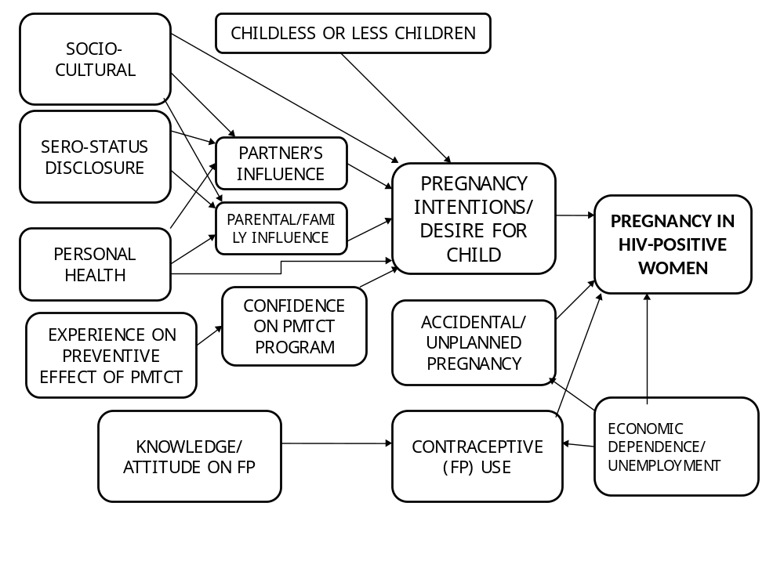

CHAPTER TWO
LITERATURE REVIEW

2.1. Introduction
This chapter will cover what has been published on the relationship between knowledge of HIV status and reproductive choices, social and cultural influences on the decision to become pregnant, and family planning practices. Previous studies on this topic have identified many challenges which HIV-positive women of reproductive age regarding the decision of having babies after knowing their HIV status (Suryavanshi et al., 2008). It is therefore important to identify and understand these challenges of repeated pregnancies among HIV-positive women of child-bearing age so that appropriate interventions, especially counseling can be put in place.
2.2. Relationship between Knowledge of HIV status and Reproductive choices
One area of importance in identifying and understanding repeated pregnancies among HIV-positive women is the relationship between knowledge of HIV status and reproductive choices. Murphy (1998) reported that although 68% of HIV-infected mothers knew their infants were at high risk of HIV transmission, 43% expected their peers would be supportive if they wanted babies and 56% anticipated positive responses from their partners. Rutenberg et al. (2000) reported that in the presence of signs or symptoms of the HIV/ AIDS illness, both women and men are overwhelmingly against continued childbearing and support the use of condoms to prevent transmission of the virus to a spouse. Many women fear getting pregnant if they suspected they were HIV positive because pregnancy would "bring out" the disease, and some women preferred taking an HIV test before having another child.
In a study conducted by Kirshenbaum et al. (2004), most HIV-positive women who became pregnant or desired children after their diagnosis seemed more confident in the efficacy of risk reduction strategies. Despite women's pregnancy experiences or intentions, reproductive decision-making participant included the perceived risk of vertical transmission, which was often overestimated; beliefs about vertical transmission risk reduction strategies; desire for motherhood; stigma; religious values; attitudes of partners and health care providers; and the impact of the mother's health and longevity on the child. Most HIV-positive women who did not want children after their diagnosis cited vertical transmission risk as the reason.
A study by Gruskin, Firestone and Ferguson (2008), showed that very little was known about how the HIV diagnosis and access to care and treatment affect women's childbearing decisions. The study also revealed that effective support of the women's reproductive decision-making in the context of HIV requires understanding of how pregnancy, reproduction and HIV interact. Also considering women to be at the center of decisions on health policy and service delivery can help provide an appropriate constellation of services.
According to a study conducted in United States by Chen et al. (2001), 28-29% of HIV-infected men and women receiving medical care in the United States desire children in the future. Among those desiring children, 69% of women and 59% of men actually expect to have one or more children in the future. The proportion of HIV-infected women desiring a child in the future is somewhat lower than the overall proportion of U.S. women who desire a child. The fertility desires of HIV-infected individuals do not always agree with those of their partners: As many as 20% of HIV-positive men who desire children have a partner who does not. Among individuals who were married or had a heterosexual partner, 46% of women and 33% of men desire children in the future.
The findings of the study conducted in Zimbambwe by Tarisai Mukotekwa (2009) on subsequent pregnancies among HIV-positive women identified in PMTCT programs revealed that increasing number of HIV-positive mothers who were aware of their status prior to pregnancy was associated with unplanned pregnancies. These (unplanned pregnancies) resulted from improved health status of the women on ARVs, patients not aware of returned fertility and also inadequate family planning couselling.
On the other hand, the study demonstrated that the planned pregnancies among HIV-positive women were associated with improved health status, social norms and individual needs. According to South Africa Journal “PlusNews” (2009) in a study on Women becoming HIV-positive during pregnancy, it was found that 3% of women who had a negative HIV test result when first accessing antenatal services, later tested positive. According to a new study published in the latest issue of AIDS, the official journal of the International AIDS Society, a number of South African women are being infected with HIV during pregnancy but not diagnosed. This study was conducted in Eastern Cape and Free State provinces between July 2006 and April 2007 by offering a repeat HIV test to women who initially tested negative at first antenatal care visit. A total of 5,233 pregnant women had registered for antenatal care and almost 80 percent accepted an HIV test; prevalence was 28 percent.
2.3. Social and Cultural influences
Motherhood forms a major social and cultural defining feature of women’s adult lives in many African countries (Dyer et al., 2002; Doyal & Anderson, 2005). It is therefore particularly difficult for married women or those intending to get married, regardless of their HIV status, to exercise a choice not to have children. Men appeared to be less pressured by family and societal expectations regarding parenthood. This underscores the gender power imbalances in intimate sexual relationships between women and men as well as the relatively less powerful position women occupy in society. There are apparent contradictions in the social pressures HIV-positive women and men experience regarding reproduction. Whether or not individuals who disclosed their HIV positive status, it surfaced as a key factor in the social pressures they encountered.
On the one hand, women who were married and who had not disclosed their HIV status felt pressured to have children to avoid raising community suspicions regarding their HIV status.
This is an important consideration for participants in a setting in which being HIV positive is stigmatized (Centre for Social Science Research, 2002). On the other hand, seeking to have children for women and men who had disclosed their HIV positive status was socially unacceptable. This is supported by evidence from another study that showed considerable stigmatization of childbearing by HIV positive women among the general populace in this setting (Myer et al., 2006).
Women found themselves particularly pressured by such attitudes, and this may have acted as a constraint to disclosure of their HIV positive status.

The results of the survey aimed at to identifying the attitudes and behaviors of HIV positive women in the U.S., revealed that 61% of the participants felt that HIV positive women can have children if they receive the appropriate medical information and support (Squires at al., 2008). However 59% believed that society strongly urges them not to have children, and caucasian women were significantly more likely than Hispanic women to feel that society strongly urges them not to have children (67% vs 53%; P= <0.05). In their conclusion, the researchers wrote, "This survey of HIV positive women revealed a dichotomy between personal and perceived societal views on pregnancy and childbearing in HIV positive women, with more than half of the participants experiencing societal pressure to forego childbearing." These results highlight the need for up-to-date, factual education regarding pregnancy and childbearing in HIV positive women among both the lay and medical communities.
According to the study conducted by Sowell (1997), there were six themes related to reproductive decisions namely: spiritual and religious beliefs, knowledge and beliefs about HIV, previous experience with childbearing, attitudes of families and sex partners, personal health, and intrapersonal motivation to have a baby. In the same study, one group of women indicated that they had fulfilled their desire to bear children prior to diagnosis; while a second group had experienced the illness or death of a child with HIV and was weary of additional pregnancies. Additionally, a third group of women indicated they would consider an accidental pregnancy, but they had no particular desire to become pregnant.
Health interventions, such as PMTCT and antiretroviral therapy, could have an important influence on women’s and men’s reproductive decisions, as they affect two important considerations around child’s and parent’s health, respectively. In Cape Town, PMTCT programmes are currently available at all public sector health centres, and uptake of HIV testing for pregnant women is 95% (Personal Communication, Beverley Draper, Western Cape Provincial Health Department, 2005). Myer et al.,( 2005), reported that having knowledge of the positive effects of PMTCT on infant health, men were more favourably disposed towards having children, regardless of the availability of ART. Conversely, among women, PMTCT in combination with the availability of ART influenced future reproductive intentions, indicating the important links for women between preventing children’s infection and maintaining their own health and ability to care for children

2.4. Family Planning Practices
Family planning programs could help clients ascertain their own risk of infection and thus reduce perinatal transmission of HIV by frankly discussing risk factors, offering HIV testing and assisting couples affected by HIV to make better choices about contraceptive methods.
A study conducted in Rwanda by Batya, Delvaux et al (2009) focused on the understanding of pregnancy intentions and contraception knowledge and use among HIV-positive and negative women in the national PMTCT program. The finding of this study showed that HIV-positive women were less likely to report wanting additional children than HIV-negative women (8% vs. 49%, P < 0.001), and although the majority of women reported discussing family planning with a health worker during their last pregnancy (HIV-positive 79% vs. HIV-negative 69%, P = 0.057), modern family planning uptake remained low in both groups (HIV-positive 43% vs. HIV-negative 12%, P < 0.001). Condoms were the most commonly used method among HIV-positive women (31%), whereas withdrawal was most frequently reported among HIV-negative women (19%).

A survey conducted on sexual functioning and activity among HIV-positive women in all phases of HIV illness (asymptomatic, symptomatic, and HIV-related illnesses) in the USA, found that although most women (90%) remained sexually active after testing HIV-positive, few used safe sex practices, with more than one-third (37%) engaging in regular unprotected sexual activity. Even though, 51% reported consistent condom use, 25.4 % reported never used condoms. Few women reported that HIV itself caused a decrease in sexual functioning. Reasons for abstinence included: no current partner (31%), no interest in sex (27%), ‘because of HIV’ (19%), physical HIV symptoms (6%), and ‘disinterested partner’ (4%). The same study showed that after testing positive for HIV. Over half of the women reported that the quality of their sexual activity had either stayed the same (31%) or improved (21%); only 11% reported that their sex life became significantly worse. So, sexual functioning did not change as a function of HIV illness stage (Ramkissoon et al., 2008).

The results of the study conducted by Rutenberg & Baek (2005) revealed that there were no differences observed in use of contraceptives between HIV-positive and HIV-negative women in the study communities, but HIV-positive women have more affirmative attitudes about condoms and use them significantly more frequently than do their HIV-negative counterparts in Kenya and Zambia.

2.5. Botswana
In Botwana, the HIV/AIDS pandemic remains the most important social and public health challenge. In Francistown, Botswana’s second largest city, pregnant women have more than 40% HIV prevalence and have had PMTCT services available since 1999. Although nearly all women have antenatal care (ANC) and deliver in hospital, HIV service uptake is relatively low, which may be due to knowledge and attitudes about PMTCT among women. About 67% of most women learned about PMTCT from clinic counselors and 74 % through the radio. In a study conducted by Tracy et al. (2003), 94% of the respondents believed that all pregnant women should be tested for HIV, but only 56% had been tested. Women who refused an HIV test, compared to women who accepted HIV test, were more likely to have unplanned pregnancies (75% vs.58%) and some were unwilling to take medications that would only benefit their infant (32% vs. 6%). The same women were also less likely to know someone who has joined the PMTCT program (11% vs. 19%) or is taking ARVs (7% vs. 19%).

2.6. Conclusion
This chapter covered what was published by other researchers on reproductive choice, social and cultural influences, and family planning practices. There is a need for counseling to facilitate informed decision-making about childbearing and childrearing because many HIV-infected adults desire and expect to have children and this has important implications for the prevention of vertical and heterosexual transmission of HIV. Furthermore, the researchers noted that as these individuals planned their families, they needed more counseling services to minimize the likelihood of HIV transmission to their partners and children and to help them meet the formidable challenges of undertaking parenthood while living with HIV. Thus, the knowledge of risks could change behavior after testing HIV-positive among women and the cultural values about child-bearing were also more powerful in infuencing behavior after testing positive.

CHAPTER THREE

METHODOLOGY

3.1. Introduction
This chapter will cover the study design, study setting, study sample and sample size, data collection methods, and ethical considerations.

3.2. Study Design
A cross-sectional descriptive survey method using qualitative inquiry was used to explore HIV positive women’s motivation to bear children despite knowing their HIV status. This is because we wanted to explore the in-depth reasons for pregnancies among HIV-positive women.

3.3. Study setting: The study was conducted in three clinics in Serowe, namely: Nutrition Clinic, Serowe Clinic, and Kadimo Clinic. The three clinics provide antinatal care and PMTCT services from Monday to Friday weekly starting 07:30 am up to 04:30 pm. Each clinic receives on average 30 to 40 clients daily (including first visit and re-visits).
Four research assistants (three trained nurses and one trained lay counselor) based on their interest in HIV program were trained to participate in this study.

3.4. Study sample
A Purposive sampling technique was used to select the participants who were women enrolled in PMTCT program because they were appropriate to respond to the questions on the phenomenon of conceiving or planning to conceive while on PMTCT program. Before sampling, the study topic was introduced as part of morning talk to all pregnant women waiting for ANC visit that specific day. The sampling was done as each pregnant woman entered in the consultation room individually. Only HIV-positive and those who consented were selected for the study. Appointment was granted either to come back to the clinic for the interview or to be followed to their home at their convenient time. A total of 26 women enrolled in the PMTCT program, were included in the study.

3.5. Data collection methods
One-to-one interviews were conducted on twenty six participants. This was preferred because we thought that an individual alone will feel free to give more information about her life or her behavior than in a focus group. We considered that one-to-one interview promote more privacy and confidentiality than focus group. Seven women were interviewed at the clinics but the majority (19) of participants was followed at their domicile at their convenient time and place. As domicile interviews were conducted after working hours, this was convenient to research assistants because they could not leave their normal duties and conduct interviews. An interview guide was designed in English and Seswana (Appendix: 2, page 39). The interviews were conducted in the local language (Setswana) by the trained research assistants. The interviews were conducted for approximately 30 to 45 minutes. The responses were recorded and reviewed in the field for completeness. The researcher and research assistants returned to the households to complete or clarify interviews when and where feasible.

3.6. Ethical Considerations
In accordance with the requirements of human subject research, prior to beginning this study, the research proposal was submitted for approval to the Research, Ethics and Publications Committee (REPC) of the School of Public Health (NSPH) and the Medical Campus Research and Ethics Committee (MCREC) at MEDUNSA Campus/ University of Limpopo including the Botswana Health Research Unit at the Ministry of Health (Appendix 6). Thereafter, Written Permission was obtained from MEDUNSA (Appendix 5). The project number is MREC/ PH/ 144/ 2008: PG

Informed consent: All participants were informed about the purpose of the study and they were free to make informed choice of whether to participate or not. Participants were assured that all data collected would be treated with absolute confidentiality and that all the records would be kept safe. Study data collection instrument did not have names or particulars linking the participants with the study.
Privacy: a room was provided for face to face interviews. Only the researcher, research assistant and the participant were present.
Autonomy: Participants were allowed to withdraw at any stage of the study without fear of being victimized or intimidated. Participant’s written consent was sought and only participants who consented were recruited for the study.

Upon completion of the study, a copy of the outcome will be available in all health facilities in Serowe, DHT office, and one hardcopy and an electronic copy of the report will be submitted to both REPCs.

3.7. Conclusion
This chapter presented the study design, study setting, and methodology. I motivated for methodological option of using cross-sectional survey as my design, purposive sampling was used in selection of participants in the three clincs.

CHAPTER 4
DATA ANALYSIS

4.1. Introduction
This data analysis chapter will cover socio-demographic data of participants, and the qualitative data analyses. The analysis of qualitative data was done manually but the excel microsolft office was used for socio-demographic data.

4.2. Data Organization
Charateristics of participants assessed include: age, marital status, living together with a partner or separated, employment, income and education level. The second part covers the qualitative data as follows: reason for pregnant; risk associated with pregnancy and HIV; decision for joining PMTCT program; partner reaction to HIV status; perception of family support. No name was used, transcripts were labeled as participant A, B, C to Z corresponding to participant 1, 2, 3, …, 26. Comments and reports from participants were presented according to the responding participant.

4.3. Characteristics of Participants
4.3.1. Age

Figure 2: Frequency distribution of participants by age (years)
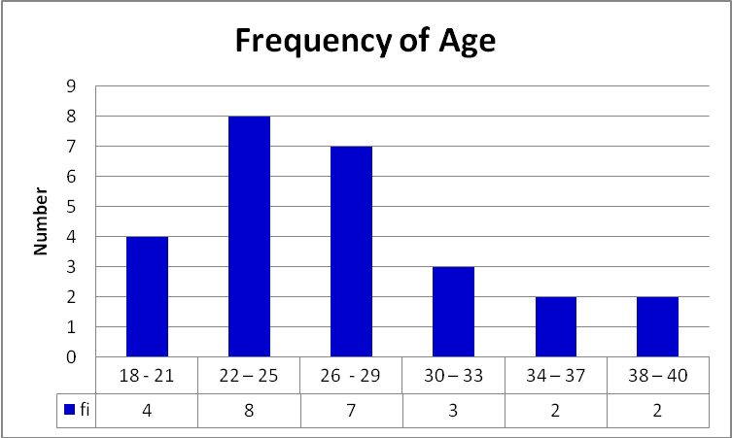
From the total number of (n= 26) participants, the minimum age is 18 years and maximum age is 38 years. The average age of the participants is 27 years and the majority of participants are aged between 22 to 25 years old, followed by those who are 26 to 29 years old.
4.3.2. Marital Status

Figure 3: Frequency distribution of participants by marital status
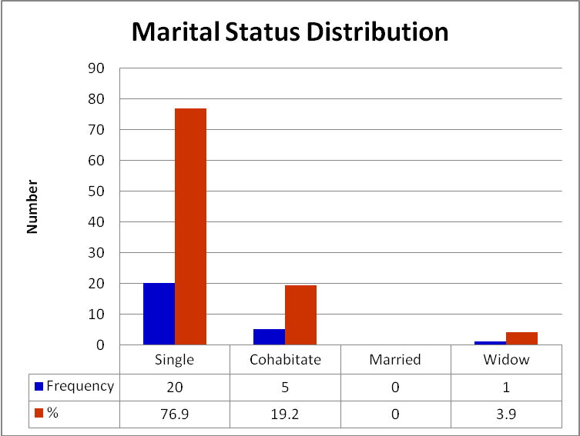
Out of 26 participants, 20 (76.9%) are singles, 5 (19.2%) cohabitate with stable partners, 1(3.9%) participant is a widow and no one was married.

4.3.3. Period in Relationship with the Partner

Figure 4: Frequency Distribution of participants by period in relationship with the partners
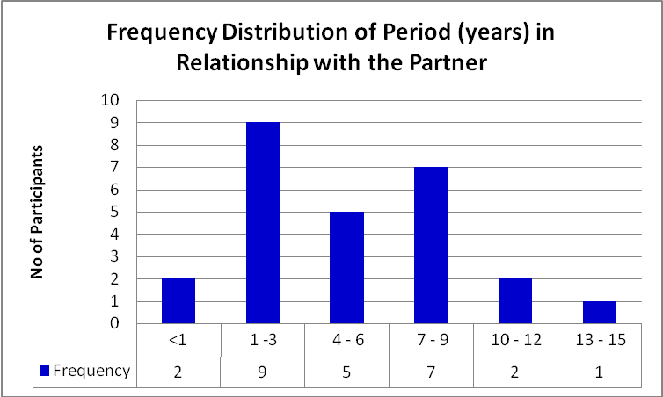

Of the 26 participants, 9 (34.6 %) participants are in relationship with their partners for a period of one year to three years, 7 (26.9 %) participants are in relationship between seven to nine years, 5 (19.2 %) participants are in relationship with their partner in a period of four to six years, 3 (11.6 %) participants are in relationship for more than ten years and only 2 (7.7 %) participants are in relationship for less than a year.

4.3.4. Living together with the partner

Figure 5: Number of participants living together with their partner
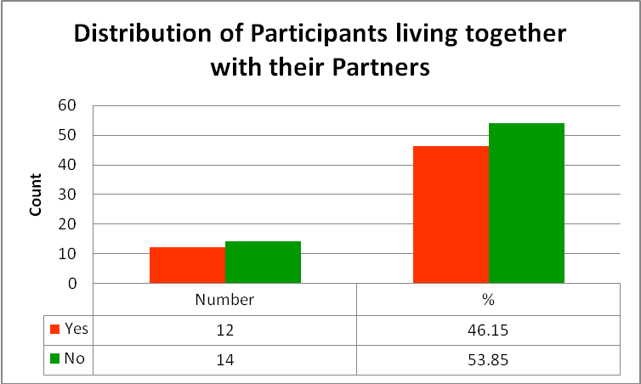
From 26 participants, 12 (46.15%) are living together with their partners and 14 (53.85%) are not living together with their partners

4.3.5. Employment

Figure 6: Frequency distribution of participants by employment

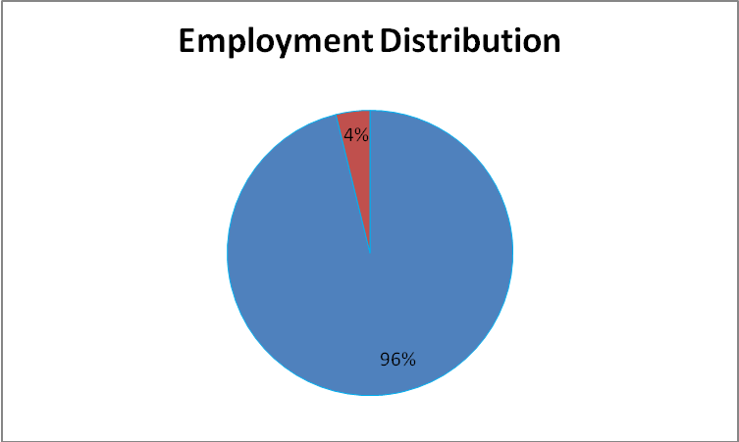
Out of 26 participants, only one (4%) was employed, while the remaing 25 (96%) participants were jobless.
4.3.6. Income

Figure 7: Frequency distribution of participants by income
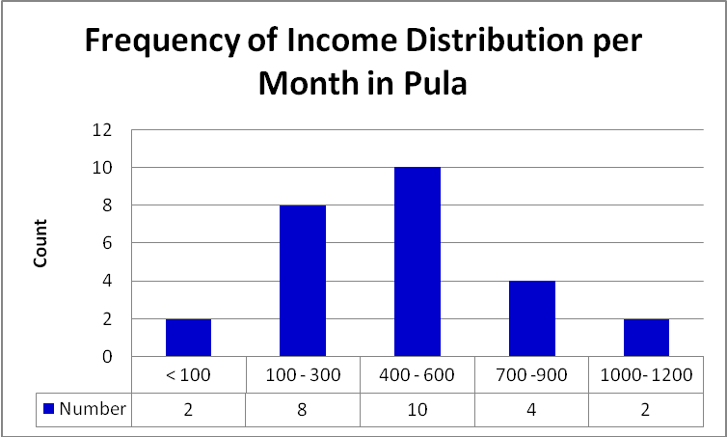
Ten (38.4 %) participants out of 26 have 400 to 600 pula as monthly income which is equivalent to about 50 to 70 US$ (USD); 8 (30.8 %) of the 26 have 100 to 300 pula; only 2 (7.7%) participants with more than a 1000 pula as monthly income and the monthly income for two others is less than 100 pula.

4.3.7. Education Level
Figure 8: Frequency distribution of participants by education level
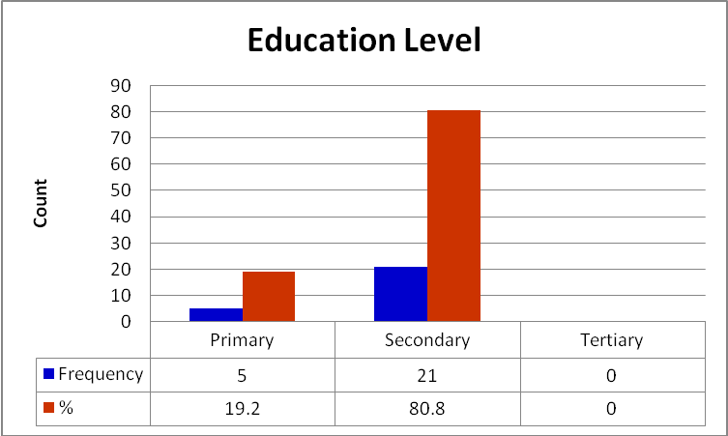
The majority of the participants 21 (80.8%) have secondary level of education, 5 (19.2%) participants have primary level, and no one has tertiary level.
4.3.9. Religious Affiliation of Participants

Figure 8: Frequency distribution of participants by religion
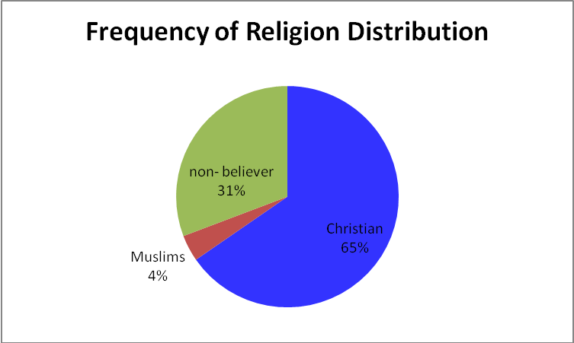

Of the 26 participants, 17 (65 %) are Christians, 8 (31 %) are non-believers and one (4%) is Muslim.

4.4. Family Planning Practices
All 26 (100%) participants had some knowledge or understanding about family planning but only 18 (69.2 %) of participants used the family planning method before they got pregnant and 8 (30.8 %) of participants did not use any family plannig method. Of the 18 participants who were on family planning, 16 (88.9 %) participants disclosed to their partners that they were on family planning or they were using it together and 2 (11.1 %) participants did not inform their partner about the use of family planning.

Figure 10: Contraceptive methods used
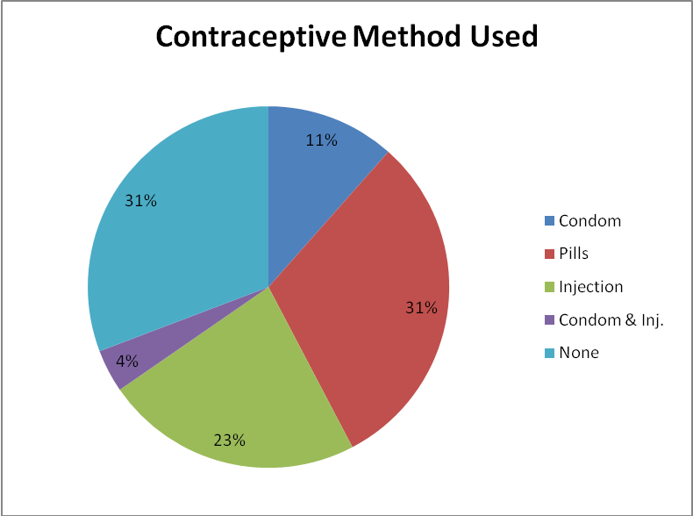

Over one-tenth (11%) of the participants reported to have been using condoms (male condoms), 8 (31%) participants were on pills, 6 (23 %) participants were using injections, one (4 %) of participants were using condoms and injections together, and 8 (31%) of participants were not using any contraceptive method.

Figure 11: Period of using contraceptive method
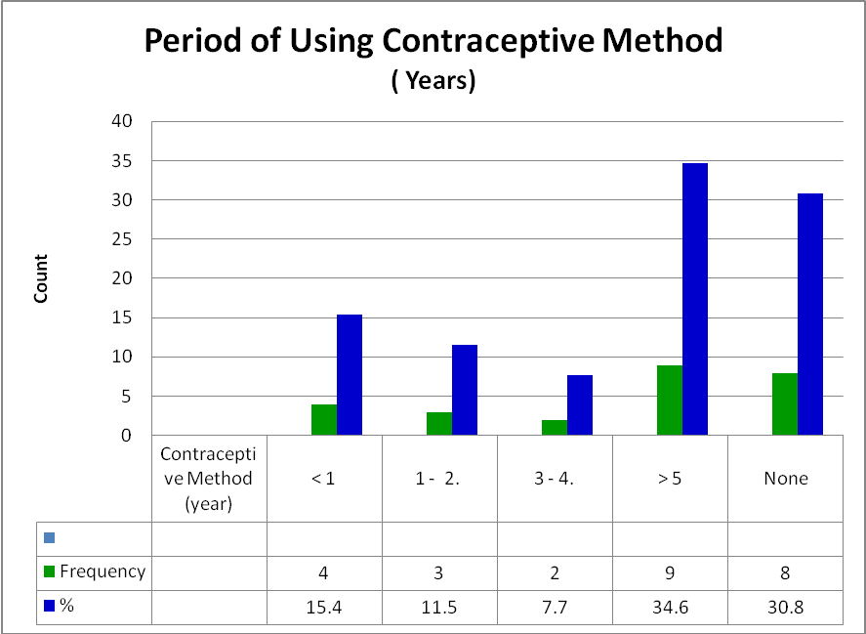
Four (15.4%) of participants used contraceptive methods for less than a year, three (11.5%) of participants used contraceptive methods for one to two years, two (7.7%) of participants used contraceptive methods for three to four years, nine (34.6%) of participants used them for more than five years, and eight (30.8%) of participants never used any contraceptive method.

4.5. Reasons of Falling Pregnant
Although about 42.3 % of participants reported that their current pregnancy was unplanned, they were not ready for the pregnancy since they already knew their HIV status (HIV- positive). When asked the question: What motivated you to get pregnant? Participants H, R, E, and X reported that “I did not expect it …” “It is an unplanned pregnancy” “I just found myself pregnant”. However, 26.9 % of participants said that they became pregnant because they desired to have another child. Statements such as “I was planning to have another child” “I wanted a baby” “I was willing to get pregnant.” were reported by participants A, C, and D. Four (15.4%) participants said they became pregnant because their male partners wanted a child. Statement such as “My boy-friend wanted a baby” “My partner wanted the baby”were reported by participants M and N. And 15.4 % of participants had no reasons for falling pregnancy. The majority (18) of participants became pregnant after they had already known their HIV status (HIV positive) and only few respondents (8) knew they were HIV positive after becoming pregnant.

Most of the participants (80.8%) disclosed their HIV status (HIV- positive) to their patners and their family members. More than half of the participants (61.5%) desired to have one to two children. Some participants desired more children, but only few participants (18.6%) are of the opinion that an HIV- positive woman should not get pregnant because they may continue to spread the HIV to their babies and their partner, and their health may deteriorate as they become pregnant. When asked the question: How many children do you want to have? And why? Or In your opinion, what do you think can be the acceptable number of children for an HIV positive woman should have? Statements such as “Only two children is okay since HIV is destroying my immune system” “Two is enough because of my health issues (HIV positive status)” “No more kids (children), five is okay as I am living positively …” were reported by participants A, D, and I.

4.6. Risk Associated with Pregnancy and HIV
Concerning the perceived risks associated with pregnancy and HIV, some respondents (41.2%) reported that the child can be infected and born HIV-positive (transmission from mother-to-child). Some respondents (17.7%) said that the health of the mother is at risk (she can become “more sick” and even die). Some respondents (14.7%) reported that the CD4-count cells of the mother can decrease, and that the immunity can be affected and viral load increased. Another group of respondents (8.8%) reported that the woman can get new virus from the partner ( re-infection). Statements such as” Some women deny, but when someone is pregnant they usually continue to have unprotected sex. This will increase their virus and they may die before time …” was reported by participant O. Some respondents (5.9%) mentioned abortion and miscarrage among the risks. The last group of respondents (11.8%) did not know the risk of pregnancy that is associated with HIV infection.

4.7. Decision to Join PMTCT Program
Majority of respondents (about two-third) had good knowledge and good understanding of the PMTCT program. They understood how the PMTCT program works and its importance in preventing mother-to-child HIV transmission. About 17 respondents reported that their decisions to join PMTCT program was based on the preventing of their unborn babies from being infected. When asked questions such as: What made you decide to enroll in the PMTCT program? What is your understanding of PMTCT program? The Following responses were noted from participants L, N, and W: “it is important to join or enroll in this program because you can get help …” “I want to give birth to an HIV negative baby.” “I don’t want my baby to be born positive.” “Because I saw the death of babies born to HIV- positive mothers but not enrolled in PMTCTprogram.”
Some of the respondents said they do not know much but they have some knowledge about the PMTCT program. They joined PMTCT program because of counselling from health professionals or relatives or friends. Answers such as “Too much counselling by hospital people at ANC and family members” “I do not know well about the program.” were recorded from particitant B and C. Some respondants joined PMTCT program because they wanted to gain more knowledge about PMTCT program. The respondant A reported“I want to know more about PMTCT program especially I am pregnant.”
There were also some respondents (P and Q) who did not know anything about PMTCT program but just joined, they said “I have just registered, I don’t know”.

4.8. Partner Reaction to HIV Status

Sixteen (16) participants reported that they informed their partners about their HIV status. Majority of partners reportedly did not react badly. According to participants, the positive reaction from their partners was due to the fact that the partners knew already their own HIV status or the HIV test was performed at the same time to both partners. When asked following questions: does your partner know about your HIV status? When, how did you tell him? How did he react? Why do you think he reacted like that? The following answers were given by the participants H, T, U, V, W and Z: “He accepted the situation …” “He was understandable person, he accepted the situation ...” “He knows there is this disease and he was interested in listening to HIV programme.” “He accepted it before I go for testing.” “He wanted a baby and I told him that I am HIV positive, he accepted because I told him” “He said we should accept the situation, there is nothing we can do. There is nothing he could do” “He is also HIV positive.” “He agreed because he said nothing.” “We tested together so it was easy as we received results and we accepted our status” “we tested together, it was easy to accept each other; we accepted.”
But some partners reportedly reacted negatively as their women disclosed their HIV status to them: “He didn’t react nicely” “He was hurt, he only thought of death” “He was angry about that, why I didn’t tell him before.” “He feels bad” “He was scared” “He did not accept; he started sleeping out...” About one-third of participants did not disclose their HIV status to their partners because they were scared of their partners; or because they did not know or were not sure what could be the reaction of the partner once he is told that his woman is HIV- positive. For some it was because the man had never disclosed his HIV status to the women; or because they did not stay together. Answers like: “I am scared about him.” “He will kill me.” “He will think that I have infected him.” “Before I get pregnant, I told him that I am HIV positive but I was joking; he was angry and also scared ...” “He has not told me his status, why should I tell him mine” “We do no stay together” “I don’t Know” “I don’t know his mood by the time I am going to tell him or it depend of his mood at the time I tell him …” were reported by participants A, B I, K, and P.

4.9. Partners’ Discussion About Child Bearing
Eleven participants did not or never discussed with their partners about child bearing. For example statement like “I have never talked about it with him.” “We have never discussed it” were reported by participant E and W. Eight participants reported that their partner advised them to stop bearing children because of their HIV status. Five participants reported that their partners wanted two children “Two. Because he want me to take care of my children” and the participant O and Z reported that their partners wanted only one child.

4.10. Family Expectations About Child-Bearing
Although the majority of participants (61.5 %) said that their family advised or encouraged them to stop bearing more children equally agreed that they were satisfied with the number of children they had. The following questions were asked: What are your family expectations about the number of children? And why? Some of the participants (V, X, and Y) gave statements like: “They are saying the number I have is okay as I am HIV positive ….” “They just encourage me not to have any more child as I am now sick so I have to take care of myself.” But about 34.6 % of the participants did not know or did not have an idea of family expectations about child bearing. About four percent (3.9%) of the participants were encouraged to bear more children by their family.

4.11. Perceptions of Family Support
Most of the respondents reported that they have good supports (social, psychological, spiritual, and financial supports) from their families and even from their partners. Following questions were asked: Can you say that you get support from your partner and/or family concerning your status? Why do you say that? Answers such as: “All of them support me” “They (family members) support me with money” They are encourraging me all the time” “Yes from my family, they support me by taking me to the hospital” “Yes, from the family, they encourage me on necessary programs” “Both family and partner, they encourage me to get services available from the clinic and get preventive measures from health workers.” “Yes, support is there as they do not discriminate me and they always encourage me to go for my reviews at the clinic.” were recorded from participants E, L, M, N, O,P, Q, T, S, and U.

4.12. Conclusion
This chapter presented data organization, the characteristics of participants, and the qualitative data. The qualitative data covered the motivation for falling pregnancy among HIV-positive women, their option to join PMTCT program, and partner’s attitude toward child-bearing. Family planning practices and familys’ perception were also covered.

CHAPTER 5

DISCUSSION

The discussions of the findings are presented in the following order: Reproductive intention which includes reasons of falling pregnant and risk associated with pregnancy and HIV. The decision to join PMTCT program and the knowledge of PMTCT program among HIV positive women will also be discussed. Then we will present the knowledge of HIV status and disclosure which include partner reaction to HIV status and partner reaction to HIV status; family expectations about child bearing and perceptions of family support; and family planning practice.

5.1. Reproductive Intention
The majority of the women (76.9%) became pregnant after they had known their HIV status (HIV positive). About 42.3% of participants reported that the current pregnancy was unplanned. There is a similarity with the findings of the study conducted in Zimbabwe by Tarisai Mukotekwa (2009) on subsequent pregnancies among HIV-positive women identified in PMTCT Program. The Zimbabwe study revealed an increased number of women who became pregnant after they have been aware of their HIV status. Their unplanned pregnancies were associated with improved health status of the women on ARVs, patients not aware of returned fertility and also inadequate family planning couselling.
Whereas a study conducted by Kirshenbaum et al. (2004) revealed that most of HIV-positive women who became pregnant or desired children after their diagnosis seemed more confident in the efficacy of risk reduction strategies. Regardless of women's pregnancy experiences or intentions, reproductive decision-making of participants included the perceived risk of vertical transmission, which was often overestimated; beliefs about vertical transmission risk reduction strategies; desire for motherhood; stigma; attitudes of partners and health care providers; and the impact of the mother's health.
A portion of women (26.9 %) reported that they became pregnant because they wanted or desired to have another child although they knew they were HIV positive. This in contrary to the study of Rutenberg et al. (2000) in which many women feared getting pregnant if they suspected they were HIV positive because pregnancy would "bring out" the disease. In Rutenberg study, both women and men were overwhelmingly against continued childbearing and supported the use of condoms to prevent transmission of the virus to a spouse.
In this study, sixty-one percents of participants reported the desire to have one to two children. Fifteen percents of participants reported that the pressure from partners was one of the reasons for pregnancies among HIV-positive. The findings in the study conducted in Zimbambwe by Tarisai Mukotekwa (2009) showed that planned pregnancy among HIV-positive women was associated with improved health status, social norms and individual needs.
Although, the sampling was not random, this study shows that 76.9 % of respondents were singles and 96 % of respondents were unemployed. This status could make women vulnerable at the point that they may not be able to take free decision on childbearing or the use of condom as these women are in financial needs and unstable relationship. Thus, they become pregnant unwillingly. In other words, being single and unemployed could easily lead to unstable relationships and contribute to repeated pregnacies.
This study has reveled also that women of reproductive age group are not only being infected with HIV more frequently, but they are becoming infected at a younger age, between the ages of 18 and 29 years
Most of the respondents (94%) in the study conducted by Tracy believed that all pregnant women should be tested for HIV, only 56% were tested. Women who refused an HIV test, compared to other women, were more likely to have an unplanned pregnancy (75% vs. 58%) and some were unwilling to take medicine that would only benefit their infant (32% vs. 6%).

5.2. Decision to Join PMTCT Program and Knowledge about PMTCT program among HIV positive women
The PMTCT services have been available in Serowe since 2000 and current data showed that the percentage of PMTCT beneficiaries is more than 90% and the percentage of HIV-positive babies born from HIV-positive mothers who were enrolled in PMTCT program is below 2% in Serowe/Palapye Sub-district. There is no much difference on how women learned about PMTCT program when comparing the results of this study to the one from Tracy et al (2003). About 69.2% of respondents in this study had good knowledge of PMTCT program and learned about the program from clinics or hospitals compared to 67% of respondents in Tracy’s study. The other portion of respondents learned about PMTCT program either from the radio, or from a family member (relative) or either from a friend. In this present study, most of the respondents reported that they enrolled on PMTCT program because they wanted to have HIV negative children as compare to 68% of respondents in study conducted by Murphy (1998).
The study conducted by Petrovic, Maimbolwa, and Johansson (2007) on primiparous mothers’ knowledge about mother-to-Child transmission of HIV in Lusaka, Zambia revealed that the majority of the women interviewed did not have basic knowledge about PMTCT. In the Lusaka study, the mothers did not know that HIV is present in breast milk and according to them the most effective way of preventing transmission of HIV to the unborn baby was a single dose of nevirapine. The overall feeling of mothers interviewed was that they had not received information and support from the antenatal clinics and postnatal wards.

5.3. Knowledge of HIV Status and Disclosure
One of the findings of this study is that majority of respondents (21) had some level of education (secondary level). They were knowledgeable about HIV infection and able to understand what it means to be HIV-positive. Most of the women (24) who knew their HIV status, had disclosed their HIV status (HIV-positive) to their family members and twenty-one participants had disclosed their HIV status to their partners. This contradicts the findings of Myer et al. (2006) who reported considerable stigmatization of childbearing by HIV-positive. Women in Myer et al’s study, found themselves particularly pressured by such attitudes, and this could have acted as a constraint to disclosure of their HIV positive status. The disclosure has not been a big issue as the results showed in this study, majority of participants supported the idea of disclosing their HIV status either to their family or to their partners. This similar to the previous report by Suryavanshi N et al. (2008) in which the results showed that repeat pregnancies were more likely to occur for women who did not disclose their HIV status to their spouses. Thus the majority of the repeat pregnancies for HIV-positive women were both unplanned and unwanted.

5.4. Family expectations about child bearing and perceptions of family support
The findings in this study showed good support of family, partners, and peers toward the reproductive decisions of HIV-infected women and this concurs with the early studies of Murphy et al. (1998) and Selwyn et al. (1989).
A study conducted by Cooper D et al. (2007) on reproductive intentions among HIV-positive women and men in South Africa revealed that family, husbands’ and societal expectations for childbearing were important influences on women's reproductive intentions, for some counterbalancing HIV as a factor discouraging reproduction.
One of the fingings in this study was also that the majority of participants stated that their family advised or encouraged them to stop bearing more children. Contrary to the study of Chinkonde, Sundby and Martinson (2009) which revealed lack of support from patner (husbands), unequal gender relations, and stigmatization as results of dropout from PMTCT. A study conducted by Cooper D et al. (2007) on reproductive intentions among HIV-positive women and men in South Africa revealed that family, husbands’ and societal expectations for childbearing were important influences on women's reproductive intentions, for some counterbalancing HIV as a factor discouraging reproduction.
5.5. Family planning practice
The findings of this study showed that although most participants seemed to know the contraceptive methods and understood the importance of these methods, only four participants were using condoms, the method which prevents both pregnancy and sexual transmitted infections (STIs & HIV). The responses from participants showed that they have knowledge of family planning through PMTCT counseling. But, family planning use was still low among HIV-positive women. This agreed with the results of a study conducted in Rwanda by Batya, Delvaux, and Munyana (2009) on pregnancy desires, and contraceptive knowledge and use among prevention of mother-to-child transmission clients. The study conducted by Bij et al (2008) in Kenya revealed similar results of low use of contraceptive. Another survey conducted in USA on sexual functioning and activity among HIV-positive women found that although most women (90%) remained sexually active after testing HIV-positive, few used safe sex practices, with more than one-third (37%) engaging in regular unprotected sexual activity.

5.6. Conclusion
The discussion shows that though the majority of pregnacies were unintentional, a portion of women became pregnant because either they desired to have another child despite knowing they were HIV positive or their partner wanted a child. Most of the participants had knowledge about PMTCT program and their choice to join the program was based on the desire to have an HIV-negative child. The use of family planning especially condoms remained low despite their knowledge about family planning practice. The disclosure to their partners and family members has not been a big issue for most of the participants.

5.7. Study Limitations
It is important to underline that there were some limitations during the course of this study. Language barrier was one of the limitations as french is my first language, english is my second language, and the data collection for the study was done in local language ( Setswana). The other limitations were that the research assistants were not researchers and had not experience in research. They were just trained nurses and trained lay-counselor.

CHAPTER 6

CONCLUSION AND RECOMMENDATIONS

6.1. Conclusion
This study revealed that women with HIV in Serowe get pregnant despite their knowledge of their health status and many of the pregnancy are unplanned. Some of participants became pregnant because they desired to have another child and others because their partners wanted a child. Factors such as fear of transmitting HIV to their child and personal health-related concerns were outlined in this study. The challenges faced by HIV-positive women in decision making related to pregnancy are so many. A proper understanding of reasons which influence repeated pregnancies in these women is very essential to guide interventions and counseling strategies to better inform and support the women. The beliefs about having a healthy baby, the personal desire and partner’s desire to have a baby, all combined with the social stigma that accompanies HIV, places women who are HIV positive in a double blind. Thus, HIV-infected women must be cautiously counseled about the risk of transmitting HIV to their infants during pregnancy and delivery. Those women who desire to either limit or space childbearing should have access to highly effective contraception. Although the majority of participants in this study had good knowledge about family planning or were aware of it, many did not use family planning. This is a great challenge and those who used family planning did not use appropriate one for their health status. This study revealed that very few HIV-positive women used condom which is the appropriate family planning method for them.
This study has also shown the success rate of the PMTCT program in Serowe given the number of respondents in the study sample who are well-informed about the program.
Participants in this study reported supportive family members, partners, and peers toward the reproductive decisions. The disclosure of HIV status of most of the participants was unproblematic to their family members and they had good social support. Additionally, this study has shown that socio-demographic factors such as being unmaried, unemployment (low income), and poverty were also most likely to be associated pregnancy among HIV-positive women.

6.2. Recommendations

There is need to put in place an appropriate guideline with proper understanding of reasons for pregnancies in women who are HIV-positive. This should contain necessary interventions and counseling strategies to better inform and support HIV-positive.

Although research is needed to demonstrate the impact of male involvement on reproductive health outcomes, efforts to reach out to partners of pregnant women at risk of HIV infection should proceed. For example, as all pregnant women who come for ANC are encouraged to do HIV test, they should also be encouraged to bring their partners for counseling or invite their partners to visit the centers for voluntary counseling and testing (VCT) and HIV prevention counseling.

The health care providers should not only concentrate on provision of condoms but should offer a comprehensive family planning service. Therefore, further efforts are needed to improve uptake of modern methods, including dual protection in PMTCT settings. And also anyone counseling an HIV-infected woman should support her family planning decisions because all women have the right to decide the number and timing of their children.

There is need to reinforce the social services for children born from infected parents and such social services may include income supplementation, housing, child care, and for those children who lose one or more parent, bereavement support, foster care or adoption.

Apart from emphasis on the risks associated with pregnancy and HIV infection, there is need for policy makers to come up with a guideline which provide information on practicable reproductive options for HIV-positive individuals.

There is need for further quantitative researches that can be generalised to the population.
A comprehensive study is needed to inform a more coordinated approach to policies and programs supporting the pregnancy intentions of women with HIV.

We suggest intervention research on contraceptive counseling, monitoring and evaluation, and partners’ behaviors.
REFERENCES

Barnes D. B. & Murphy S.(2009). Reproductive Decisions for Women with HIV: Motherhood's Role in Envisioning a Future. Qualitative Health Research, Vol. 19, No. 4, 481-491 (2009)

Batya E, Delvaux T, Munyana E, (2009). Pregnancy desires, and contraceptive knowledge and use among prevention of mother-to-child transmission clients in Rwanda. November 2009 - Volume 23 - Issue - p S19-S26

Bij S. C., et al. (2008). Family planning and safer sex practices among HIV-infected women receiving prevention of mother-to-child transmission services at Kitale District Hospital (Kenya). East Afr Med J. (2008), Vol. 85 No. 1, pp. 46-50.

Chen J.L. et al.(2001). Fertility Desires and Intentions of HIV-Positive Men and Women.Family Planning Perspectives. Volume 33, Number 4, July/August 2001.

Central Statistics Office, (2009). Botswana HIV/AIDS Impact Survey III (BAIS III): Statistical Report 2008. Gaborone, Botswana: Central Statistics Office. Web-site: www.cso.gov.bw

Central Statistics Office,(2005). Botswana AIDS Impact Survey II: Statistical Report 2004. Gaborone, Botswana: Central Statistics Office: 35.

Chinkonde J. R., Sundby J., and Martinson F. (2009). The prevention of mother-to-child HIV transmission programme in Lilongwe, Malawi: why do so many women dropout. Reproductive Health Matters, Volume 17, Issue 33, May 2009, Pages 143-151

Crago A, (2006). Health Women & AIDS in Africa, June 2006, Vol.19 Number 6.

Creek T. L. et al. (2004). XV International AIDS Conference 11th – 16th July 2004, Bangkok, Thailand, Botswana Abstract Book, July 2004 pp 26-29.

Cooper D et al., 2007. ‘‘Life is still going on’’: Reproductive intentions among HIV-positive women and men in South Africa. Social Science & Medicine 65 (2007) 274–283. University of Cape Town, Cape Town, South Africa
Cooper E et al. (2002). J AIDS.

EngenderHealth/UNFPA,(2006). Sexual and Reproductive Health Needs of Women and Adolescent Girls living with HIV; Research Report on Qualitative Findings from Brazil, Ethiopia and the Ukraine

Erande A., Pisal H., et al. (2008). Repeated Pregnancy amang women with known HIV status in Pune, India

Gruskin S., Firestone R., and Ferguson L.(2008). HIV and Pregnancy Intentions: Do Services Adequately Respond to Women's Needs? October 2008, Vol 98, No. 10 | American Journal of Public Health 1746-1750.
Henry J. K. (2001). Public Health & Education | Study Charts Childbearing Desires and Expectations Among HIV-Positive Men and Women. Daily HIV/AIDS Report Jul 26, 2001.

Kirshenbaum S.B. et al. (2004). "Throwing the Dice": Pregnancy Decision-Making among HIV-Positive Women in Four U.S. Cities, Perspectives on Sexual and Reproductive Health, 2004, 36(3):106-113. http://www.guttmacher.org/pubs/psrh/ful/3610604.pdf

Kuyoh M. and Best K.(2001). FHI-HIV- positive Women Have Different Needs. Reproductive Health. Network 2001, vol. 20, No. 4
http://www.fhi.org/en/RH/pubs/network/v20_4/NWvol20_4HIVposwomen.htm

Miller W.B. (1994). Childbearing motivations, desires, and intentions: a theoretical framework, Genetic, Social, and General Psychology Monographs, 120(2):223-258.

Mukotekwa T. (2009). Subsequent pregnancies among HIV-positive women identified in PMTCTprograms: An emerging trend in maturing programs from Zimbabwe. OPHID trust 2009 HIV Implementers Meeting Windhoek, Namibia, 10 –14 June 2009

Murphy D. A., Mann T., O’Keefe Z., Rotheram-Borus M. J. (1998). Number of pregnancies, outcome expectancies, and social norms among HIV-infected young women, 17(5):470-5.

NACA (National AIDS Coordinating Agency), 2003.Status of the 2002 National Response to the UNGASS Declaration of Commitment on HIV/AIDS.Gaborone, Botswana: National AIDS Coordinating Agency.
http://www.unaids.org/en/geographical+area/by+region/sub-saharan+africa.asp
www.naca.gov.bw

Nobrega A. et al. (2007), AIDS Patient Care and STDs; Desire for a Child Among Women Living with HIV/AIDS in Northeast Brazil.Apr 2007, Vol. 21, No. 4: 261 -267.

Ntumy R. et al., (2003). Knowledge, Attitudes, and Practices Regarding Prevention of Mother to Child Transmission of HIV (PMTCT) among Antenatal and Postnatal Women- Botswana, 2003, XV International AIDS Conference 11th – 16th July 2004 Bangkok, Thailand, Botswana.Abstract Book July 2004.National AIDS Coordinating Agency (NACA). www.naca.gov.bw

Petrovic K., Maimbolwa M., and Johansson E.(2007). Primiparous mothers’ knowledge about mother-to-Child transmission of HIV in Lusaka, Zambia; Midwifery, Volume 25, Issue 6, December 2009, Pages e1-e10
Ramkissoon A et al. (2008). Options for HIV-positive Women; Reproductive Health & HIV Research Unit (RHRU), University of KwaZulu-Natal; the International Community of Women Living with HIV and AIDS (ICW)

Rutenberg N. & Baek C.(2005). Field experiences integrating family planning into programmes to prevent mother-to-child transmission of HIV. Stud Fam Plann. (2005), Vol. 36 No. 3, pp. 235-245

Rutenberg N., Biddlecom A E, Kaona F. A. D. (2000). Reproductive Decision-Making in the Context of HIV and AIDS: A Qualitative Study in Ndola, Zambia, International Family Planning Perspectives, Vol. 26, No. 3 (Sep., 2000), pp. 124-130
Sexual and Reproductive Health Needs of Women and Adolescent Girls living with
HIV, Research Report on Qualitative Findings from Brazil, Ethiopia and the Ukraine, July 2006, EngenderHealth/UNFPA

Shonda M. et al. (2007), Pregnancy Decisions Among Women with HIV. AIDS Behavior 2007 November; 11(6): 927- 935

Squires K., Bridge D.A., et al. (2008). Social stigma of pregnant HIV-infected women in the US; XVII International AIDS Conference (AIDS 2008), Mexico City. August 3-8, 2008.

SOUTH AFRICA: Women becoming HIV-positive during pregnancy - study JOHANNESBURG, 24 June 2009 (PlusNews). http://www.Plusnews.org accessed Tuesday 17 November 2009
Sowell R. (2007). Decisions to have a baby by HIV-infected women. Western Journal of Nursing Research 1997; 19:56–69
Sowell R. L., Murdaugh C.L., Addy C.L., Moneyham L., & Tavokoli A.(2002). Factors influencing intent to get pregnant in HIV-infected women living in the southern USA. AIDS Care. 2002;14(2):181–191.
Suryavanshi N. et al. (2008). Repeated pregnancy among women with known HIV status in Pune, India.

UNAIDS (2009, November), 'AIDS epidemic update'

Wilson T.E et al., Contraception use, family planning, and unprotected sex: few differences among HIV-infected and uninfected postpartum women in four U.S. states, Journal of Acquired Immune De.ciency Syndromes, 2003, 33(5):608–613.

www.avert.org/aids-botswana.htm AVERT, 2009

APPENDIX 1: CONSENT FORM FOR PARTICIPANT

CONSENT FORM / FOMO YA MAIKANO
Consent to participate in a Research Study: Factors which influence pregnancy decision-making among HIV-positive women in Serowe, Botswana.
- Ikaniso ya go tsaya karolo mo dipatlitsong; dikgwetlho tsedi ka bakang gore mme yoo nang le mogare gore felele a imile Serowe, Botswana.
Principal Investigator: Dr Muya Kanyinda
- Moeteledi pele wa dipatlesiso: Dr Muya Kanyinda
1. Participation in a research study. By signing this form, you are consenting to
participate in the above research study.
- Motsaa karolo mo dipatlisisong tsa dithuto.Go baya monwana mo pampering ya patlisiso ke seitlamo sa go tsaya karolo.
2. Purpose of the research: In this study we are going to try and answer the
following objectives:
- Bomosola ba patlesiso: mo dapatlisong tse retla leka go araba dipotso dingwe le go rarabolela mabaka mngwe a latelang:
a) To identify the factors which influence pregnancy decision-making among HIV-positive women in Serowe.
- Go batlisa mabaka a a rotloetsang bomme baba naleng le mogare go I ma/gonna le bana mo Serowe.
b) To gather an understanding of PMTCT program and vertical transmission among HIV positive women in Serowe.
- Go batlisisa kitso ka lenaneo la thibelo mogare gotswa kwago mmaagwe yo itsholofetse goya kwa loseeng mo bomme baba tshelang ka mogare wa HIV.
c) To describe the perception of HIV positive women about to family planning methods.
- Go tlhalosa ponelo pele le kama o dumelang ka teng kaga bomme baba itsholofetseng banale mogare wa HIV.
3. Number of research participants: We hope to recruit approximately 20 to 30 clients from the ANC clinics to participate in this study.
- Palo ya ba batsaya karolo: Resolofela go nna le batsaya karolo bale masome a mebedi goya kwa masomeng a mararo ba batlang kokelong ya tshidilo.
4. Duration of Study Participation: You are being asked to participate in this study for as long as you are required.
- Sebaka se patlisiso etla setsayang: O kopiwa go tsaya karolo nako nngwe le nngwe fa go tlhokega goya kwa phelelong.
5. Study Procedures: We will ask you to attend an in depth interview with our
Research Assistant. The information you give will be recorded and kept as long as they are required. We may request you for another interview for clarification of some issues that might not be quite clear the first time. The interview will be conducted at your convenient time and place.
- Tsamaiso/thulaganyo ya patlisiso: Re kopa gore o tsenelele puisanyo ya rona ka botlhalo le babotsodisi.Dikarabo tsa gago ditla bewa go musa mo pathisisong.Potsoloso engwe eka nna ya dirwa gape gotla go tlhalosa mabaka mangwe akatswang asa tlhaloganyesege mo potsolosong ya ntlha.Otla epeela nako le lefelo le otla botsolotswang teng.
6. Risks Associated with Study Participation: There are no risks associated with participating in this research except that some of the questions may be sensitive and personal.
- Ditlamorago/bodipatsa tsa go tsemelela patlisiso;Ga gona ditlamorago tsago tsenelela patlisiso ye ntlheng le gore dipotso dingwe dika gogo mosa maikutlo kgotsa ele sepiri se oneng osa batle go se ntsha.
7. Benefits Associated with Study Participation. There are no direct benefits to you associated with participating in this research. Ultimately, the results of this study could help us improve the reproductive health services rendered to HIV positive women in our Serowe community and in Botswana.
- Mosola wa go tsaya karolo mo dipathisong;ga gona dikatso dipe mogo tseyeng karolo mo dipatlisong lefa gontse jalo ekare thusa go fetola,gotokafatsa tsamaiso tsholo mogo go bmme baba tshelang ka mogare mo Serowe.
8. Alternatives to Participation. You do not have to participate in this study in order to receive services from the ANC clinic. You are free to participate or not in this study. You are not forced you may decide to quit participating in this study at any time.
- Gokgetlha go tsaya karolo: Go tsaya karolo mo dipathisong goago ame gope katsa tshidilo.O ikgethela go tsenelela kana gosa tseneleleng.Mo tsamayong ya nako o ka nna wa ikgethela go boela morago.
9. Confidentiality. We promise to maintain the confidentiality to the extent
allowable by law of any information about you. Study records using your name will
be maintained, but only study investigators will have access to this information.
Summary data that does not identify individual patients may be presented in
scientific meetings and journals. You have the right to determine who has access to
your personal health information. The personal health information collected in this
study may include your medical history, obstetric history and family planning history
including HIV status as well as basic demographic information. By signing this
consent form, you are authorizing the researchers to have access to your personal
health information. Your personal health information will not be used or disclosed to
any other person or entity. Your personal health information will be used only for
the research purposes described in the Introduction of this consent form and
individual participants will not be identified in any presentations or publications
based on the results of the research study. Your personal health information will be used until the study is completed. You may cancel this authorization in writing at any time by contacting the principal investigator. If you cancel the authorization, then you will be withdrawn from the study.
- Sephiri: Dikarabo tsa gago etla nna sephiri sa gago le nna.Mokwalo mongwe wa dikarabo yo naleng leina la gago ditla dirisiwa ke babatlisisi fela.Melaetsa mengwe ya tshoboko etla gatiswa mogo tsa boranyane mme gosa kwalwe leina/maina aba tsaya karolo.O nale tshwanelo ya go letlelela mongwe go bona sephiri sa gago sa botsogo.Mo pathisisong yee go kanna ga batliwa botsogo jwa gago ka kakaretso,ka pelegi,ka tsa katologanyo tsholo le seemo sa gago sa mogare le botshelo jwa gago jwa lelwapa.Kago baya manwana mo pampering ee o letleng ba botsholisi gago botsa ka tsa botsogo ja gago.Mme sepe seo se bueleng gasena go bonwa ke ope kgotsa go bolelelwa batho.Seemo sa botsogo ja gago setla dirisaw fela mo dipathisisong jaaka go tlhalositswe kwa tshimologong le leina la motsaga karolo etla tshwelela ele sephiri mo tshobokong ya dipathisiso.Dikarabo ka seemo sa botshogo jwa gago ditla diriswa jwa gago ditla diriswa go fitlhelela bokhutlo jwa dipathiso.Go ikgogela morago botsogo jwa ditla diriswa go fitlhela bokhutlo jwa dipathiso.Go ikgogela morago mogo tseyeng karolo oka go dira nako nngwe mme oka ikgolaganya le moeteledi pele wa dipathisiso.Gao ikgogele morago mo dipatlesisong,otla ntshiwa mo dipatlisong.
10. Questions: If you have any questions about this research or regarding your rights as a participant in this, you can contact the principal investigator Dr Muya Kanyinda at these numbers: (267) 4635890/ 4635888/ 4600795.
- Dipotso: Ga onle dingwe mabapi le dipatlhesiso kgotsa mabapi le ditshwanelo tsa gago ole motsaya karolo o ka ikgolaganya le mmatlhisi mogolo Dr Muya Kanyinda: (267) 4635890/ 4635888/ 4600795.
11. Payment for Participation. You will not receive any payment (money or gifts) for participating in this study. However, travelling expense will be given if you are requested to come again and if this is within the distance range of 10 kilometers or more.
- Dituelo tsago tsaya karolo: Ga gona dikatso dipe tsa madi kgotsa dimpho mogo tseyeng karolo mo dipatisisong,lefa gontse jalo ditshenyegelo tsa mosepele otla di duelelwa ga gotlhokeng gore o boelele gape,mme gotla nna jalo fela mo sekgeleng sa dikilometara tse lesome le gofeta.
12. Costs of Participation: There are no additional costs associated with
participating in this study.
- Dikatso tsa motsaya karolo: Ga gona dikatso dipe tsedi tla newang motsaya karolo mo dipatlhesisong.
13.Voluntary Participation. Your participation in this study is purely voluntary.
You will not be treated any differently or you will not be denied services to which
you are entitled, if you do not want to participate or if you withdraw your consent to
participate. You may stop your participation at any time.
- Goithaopa go tsaya karolo: Go tsaya karolo mo dipatlhisisong kegwa baithopi fela.Ga ona go bona dithuso dingwe tsedi farologanye kgotsa ga ona go iletswa dithuso dipe tsedi go lebaganyeng lefa osa batle go tsaya karolo kgotsa o batla go ikgogela morago mogo tseyeng karolo.O ka ikgogela morago mogo tseyeng karolo nako nngwe le ye o batlang.

CONSENT / IKANISO
a) I have read the description of the research study as outlined above. The study representative has explained the study to me and has answered all of the questions I have at this time. I have been told that there are no risks or benefits associated with participating in this study. I will receive a copy of this consent form.
- Ke badile tlhaloso ya dipatlhisisojaaka enankotswe fa godimo.Babotsulitsi bane ba ntlhalosetsa ka dipatlhisiso lego araba dipotso tseke neng kenale tsone ka nako ee.Ke boleletswe gore ga gona dithamorago kgotsa dikatso dipe mogo tseyeng karolo mo dipathisisong.Ketla amogela moriti wa pampiri ya ikaniso.

b) I freely volunteer to participate in this study. I understand that I am not forced to take part in this study and that my refusal to participate will not involve any penalty or loss of my rights to which I am entitled. I further understand that I am free to later withdraw my consent and discontinue my participation in this study at any time. I understand that refusing to participate or later withdrawing from the study will not adversely affect my subsequent medical care.
- Ke ithaopa ka tshosologo ke go tsaya karolo mo dipatlhisiso.Ke tlaloganya gore gake patelediwe go tsaya karolo mo dipatlhisisong,le gore gosa batleng go tsaya karolo game go tsaya game ga gona go nkama gope le gone go lathegelwa ke ditshwanelo tsame.Goya pele ke tlhaloganya gore morago gago tsenelela dipatlhisiso ke gololosegile go ikgogela morago mo maikanong ame le gone go emisa go tsaya karolo mo dipatlhisisong nako nngwe le nnwe.Ke tlhaloganya gore gosa tseyeng karolo game kagotsa go ikgogela morago mo tsweledisong ya dipathisiso ga gona go kgoreletsa dithuso/ditlamelo dipe tsa botsogo.

………………………………………. … ……………………
Signature of Research Participant Date
Monwana wa motlhotlhosisiwa letsatsi

………………………………………….. …………………….
Signature of Person Obtaining Consent Date
Monwana wa motlhotlhomisi letsatsi

…………………………………………….. ……………………
Signature of Witness to the Consent Procedure Date
monwana wago letsatsi

…………………………………………. …………………….
Signature of Principal Investigator Date
monwana wa motlhotlhomisi mogolo letsatsi

APPENDIX 2: ENGLISH INTERVIEW GUIDE

Interview Guide
Introduction
The researcher is talking to some of the women who are in the PMTCT programme in clinics about their need of having family and how they decide and plan for their accomplishment. The researcher wants to better understand factors which influence pregnancy decision-making among HIV-positive women, their understanding of PMTCT program and vertical transmission and their perceptions and beliefs about family planning methods.
Please remember that all the information you will give will be very confidential, and you can opt not to answer some of the questions on issues you do not want to discuss.
We expect that each interview will be 45 minutes long.

a) Socio- demographic
- How old are you?
- What is your marital status? Single ( ), Single with a stable partner/cohabitate ( ), Married ( ), Widow ( ), Divorced/ separated ( ).
- How long have you been in your relationship?
- Are you living together?
- Can you tell me about your relationship with your husband’s (partner’s) and your family members?
- How much money do you get each month?
  - Do you work? How much money do you get each month from this work?
  - Do you get money from anywhere else or from anyone else? For example, do you get any government grants, money from family, partners, and friends?
  - Altogether, how much money do you get each month?
- How did you first find out about the PMTCT program?
- When did you enroll in the program?
- What made you decide to enroll in the PMTCT program?
- How long have you known your HIV status? < 1 year ( ), 1-5 years( ), >5 years( )?
  - When did you know your HIV status? Before or after the current pregnancy?
  - Tell me a bit how you arrived to know HIV status. Was it motivated by ANC visit or it was a VCT?
- Does your partner know about your HIV status?
  - If No,
    - Why have you not told him?
    - How do you think your partner will react if you can tell him?
    - Why do you think he will react like this?
  - If Yes,
    - When did you tell him
    - How did you tell him, what did you say
    - How did he react
    - Why do you think he reacted like that?
    - How did this affect your relationship?

- Does anyone in your family know about your HIV status?
- If no,
    - Why have you not told anyone (them)?
    - How do you think your family members will react if you tell them?
    - Why do you think they can react like this?
- If yes,
    - When did you tell him/her/them?
    - How did you tell him/her/them? What did you say?
    - How did s/he react?
    - Why do you think s/he reacted like that?
    - Has your HIV status affect your family relationship? How?
- Can you say that you get support from your partner and/or family concerning your status? Why do you say that?
- What is your level of your education? Primary ( ), secondary ( ), tertiary (college or university?) ( )
- What is your religion / denomination: Christian ( ), Muslims ( ), non- believer ( ), others ( )
- What are your partner’s expectations about child bearing and the number of children? And why?
- How many children do you want to have? And why?
- What are your family expectations about the number of children? And why?
19. Have you been pregnant since knowing your HIV status?
If yes,
- How was the conditions of the when you delivered? Live birth/Still Birth/Abortion.
- What was the HIV status of the child?
20. Can you say that your HIV status is influencing your decision of the desired number of children? If yes, how?
21. Is there anything else that you think is influencing your decisions about the number of the children you want? E.g. family, in-laws
22. In your opinion, what do you think can be the acceptable number of children for an HIV positive woman could have?

b) Understanding
23. What are the risks of unprotected sex in HIV positive women?
24. What motivated you to get pregnant?
25. Did you know of contraception before you were enrolled in the PMTCT program?
  - Did you use it?
  - What type?
  - Why did you choose to use it?
  - For how long did you use it?
  - Was your partner aware that you are using it?
26. Do you think there is any risk associated with pregnancy when someone is HIV positive? If yes, what risks are you aware off?
27. What is your understanding of PMTCT program?
28. What was your experience of the PMTCT program?

Closure: We have now come to the end of our interview. I thank you for your openness, input and time. If you have any questions about what we have discussed, please feel free to ask me now.”
APPENDIX 3: SETSWANA INTERVIEW GUIDE

Ditselana tsa potsoloso
Tshimologo
Ke buisanya le bangwe ba bomme baba mo lenaneong lago thibela mogare gotswa mogo mmangwana goya kwa loseeng mo kokelwaneng ya rona.Ke batla go nonotsha kitso yame ka mabaka kgotsa dikgwetlho tsedi rotloetsang mme yoo tshelang ka mogare a felele a imile,go tlaloganya ga goga ga lenaneo la PMTCT,dikakanyetso le ditumelo tsa gago mabapi le katologanyo tsholo ya gago.
Tswee tswee gakologelwa gore sepe sere se bulieng mmogo ke sephiri same le wena le gore dipotso dingwe oka nna wa ikgetlhela goseke odi arabe.
A)TSA KWA GAE
1. Ngwaga tsa gago dikae?
2. A o nyetswe? Ga kea nyalwa( ),Ke nyetswe ( ),Ke tlhadilwe( ),Ke swetswe ( )
3. O nale lebaka le le kae mo botsalanong jwa gago?
4. A le nna mmogo?
5. Botsalano ja mokapelo,monna wa gago le ba lwapa la gago bo ntse jang?
6. O bona selekanyo sele kae sa madi kgwedi le kgwedi?
a) A o a bereka? O ogolola bokae ka kgwedi?
b) A o tsaya madi golo gongwe kgotsa mo go ba lelwapa,mokapelo,le ditsala?
c) Mo ditseleng tsotlhe ka kakaretso o nna le bokae jwa madi ka kgwedi?
7. O isile jang lantlha ka lenaneo la gothibela mogare gotswa kwago
mmangwana yoo itsholofetseng go ya kwa loseeng?
8. O simolotse leng go tsenenela lenaneo la gothibela mogare gotswa kwago mmangwana yoo itsholofetseng goya kwa loseeng leng?
9. O gwetlhilwe ke eng go tsenelela lenaneo la gothibela mogare gotswa kwago mmangwana yoo itsholofetseng goya kwa loseeng?
10. O nale lebaka le le kae o itse seemo sa gago sa mogare wa HIV?Ngwaga
legoya tlase ( ) ngwana ole mongwe goya kwago tse tlhano ( )ngwana tse
tlhano le gofeta( )
a) O itsile leng seemo sa gago sa mogare? Pele kgotsa morago ga boimana jwa
gompieno?
b) Go tsile jang gore o itse seemo ga gago sa mogare,a e ne ele kgwetlho ya ikwadiso boimana kgotsa one o tsile fela go itlhatlhoba.
11. A mokapelo/monna wa gago o itse seemo sa gago sa mogare?
a) Fa a sa itse,
i.Ke eng o sa mmolelela
ii.O tsaya gore mokapelo wa gago ptla tseega jang fa o ka mmolelela
iii.Ke eng o akanya gore o ka tseega jalo
b) Fa a itse,
i.O mmoleletse leng?
ii.O mmoleletse jang,o reng?
iii.O ne a tseega jang?
iv.O akanya gore ke eng a ne a tseega jalo?
v.Gone ga kgoreletsa botsalano jwa lona jang?
12. A go nale mongwe mo go ba lelwapa yo a itseng seemo sa gago
a) Fa go sena ope?
i.Ke eng o sa bolelela ope
ii.O akanya gore ba lwapa la gago ba tsile go tseega jang
iii.Ke eng o akanya gore ba tsile go tseega jalo
b) Fa o ba boleletse,
i. O ba boleletse leng
ii. O ba boleletse jang?O reng?
iii. Ba ne ba tseega jang?
iv. O akanya gore ke eng a ne a tseega jalo?
v. A seemo sag ago sene sa ama botsalano jag ago le ba lwapa la
gago jang?
13. A o bona thotloetso mogo mokapelo kgotsa ba lwapa la gago mabapi le seemo sa gago?Tlhaloso karabo ya gago?
14. O fitlhetse fa kae mo dithutong tsa gago:dithuto tsedi potlana( ),dithuto tsedi kgolwane( ),duthuto tsa ithutelo ditiro( )
15. Tumelo ya gago ke eng:sekeresete( ),Muslims( ),yoo sa dumelang( ),nngwe ntleng mo go tsedi nankotsweng...........................
16. Ditsholofelo tsa mokapelo/monna wa gago mabapi ka tsholo ya bana ke eng?Tlhalosa karabo ya gago?
17. O batla go nna le bana bale kae?Ka goreng?
18. Ba lelwapa la gago ba solofela eng ka palo ya bana ba gago?Ka goreng?
19. A o kile wa ima fa o sena go itse seemo sa gago sa mogare?
Fa go ntse jalo:Seemo sa ngwana a tsholwa,
A tshela( ),
A tlhokafetse( ),
A senyegetswe( )
20. A o kare seemo sa gago sa mogare ke sone se rotlotsang tshwenyo ya palo ya bana?Fa go ntse jalo ka go reng?
21. A go nale sengwe gape se serotleetsang tshwenyo ya palo ya bana ba o ba batleng?Jaaka ba lelwapa,bo matsalaago?
22. Go ya ka wena,o go tshwanetse ga nna le palo e mosadi yoo tshelang ka mogare a nne le bana ba le kae?

b)KITSO/TLHALOGANYA
23. Ke eng bo diphatsa jwago thakanela dikobo osa itshireletsa o nale mogare wa HIV?
24. Ke eng se se go gwetlhileng go ima/goitsholofela?
25. A o ne o itse sengwe ka itshereletso/thibelo boimana pele o tsenela lenaneang la PMTCT?
a) A o ne wa e dirisa?
b) Ya mofuta ofe?
c) Ke eng o ne o tlhopha goo dirisa?
d) O dirisitse mofuta o lebaka le le kae?
e) A mokapelo wa gago one a lemoga fa o se dirisa?
26. A o akanya fa go nale diphatsa mo mmeng yoo imang a tshela ka mogare.Fa go ntse jalo,o itse dife diphatsa?
27. O tlhaloganya eng ka lenaneo la thibelo mogare go tswa mo go mmangwana go ya kwa leseeng?
28. Maitemogelo a gago e nnile ka lenaneo la thibelo mogare go tswa mo mmangwaneng go ya kwa leseeng?
Konetelo;Re gorogile bokhutlo jwa potsoloso ya rona.Ke lebogela go phuthologa ga gago,go nna le seabe le yona nako ya gago.Fa o nale dipotso dingwe mabapi le sere satswang gose buisanya o gololesegile godi mpotsa gompieno.

APPENDIX 4: LETTER FOR PERMISSION TO REPC
Dr Muya Kanyinda
P.O. Box: 3104
Serowe
Botswana.
March 4th, 2008
The Chairperson
Research, Ethics and Publications Committee (REPC)
National School of Public Health
University of Limpopo
MEDUNSA

Dear Sir/Madam,
RE: PERMISSION TO CONDUCT RESEARCH BY MYSELF:
MUYA KANYINDA, STUDENT NO. 200725929
I am hereby requesting for permission from the Research, Ethics and Publications Committee to conduct the above-mentioned research in Serowe Clinics as per the requirements of the degree of the Master in Public Health.
I have proposed to conduct a study titled: Reasons for pregnancy among women on PMTCT Program in Serowe-Botswana
I hope the results of this study will bring out factors that influence the reproductive options of HIV positive women. I am hoping for some in depth sense of what HIV positive women think and feel about pregnancy decision-making and hopefully, this would help the policy-makers to develop appropriate family planning and reproductive health interventions.
We expect that each interview with a participant will be 45 minutes long.
I am looking forward to your favourable consideration of my request.

Please find attached my Research proposal.
Yours faithfully,

Muya Kanyinda
APPENDIX 5: CLEARANCE CERTIFICATE
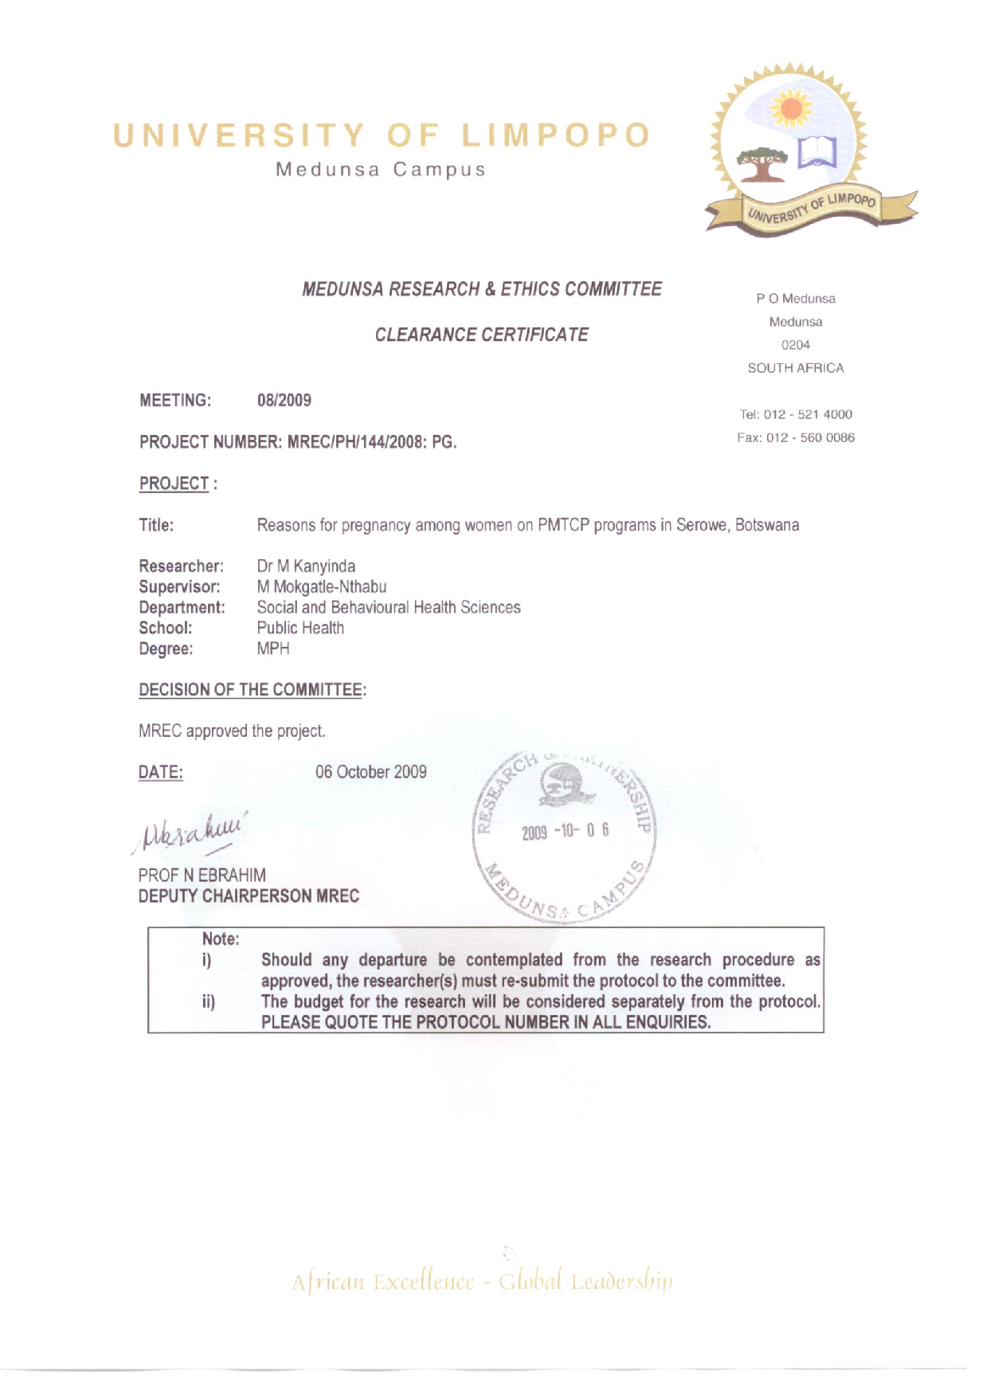

APPENDIX 6: DATA COLLECTION CONFIRMATION SHEET


